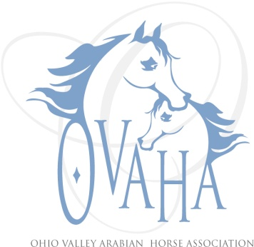

2014 Meeting Attendance/Minutes

Date of Meeting: ___1-11-2014__

P Officers P Board Members P Committee Chairs
P | Sherri Lewis - President |  | Tammi Dawson (‘14) |  | Becky Pitcock (Mbr)
P | Matt Herder - Vice President |  | Pam Brooks ('13) |  | Laraine Hune (TAIL)
P | Sharon Hanks - Secretary | P | Kristin Herder (’13) |  | Denise Mealy (Web)
 | Denise Mealy - Treasurer |  | Susan Carter ('13) | P | Joe Subler (Hospitality)
 | Marcia Doncaster Past President (resigned) | P | Linda Laufer (’14) |  | Sharon Hanks (SS)
 |  |  | Mark Ross(’14) |  | Claire Williams (Youth)
N | Quorum
Meeting: Regular or Special (also Annual meeting)
Notice given: Via e-mail, web page and Facebook page
Also present: Jim Baumgarner, Larry Kinneer, Tammy Hawkeye, Kari Lampe, Trv-lyn Matta, Joanie Subler, also representatives from Miami County Equine Initiatives Task Force (MCEITF), Freedom Equestrian Team, and the Equestrian Center at Safe Haven Farms.

Location and Time: Trv-lyn Matta's house, at4:45.

Went through elections, no names were submitted for officers or board positions. Matt presented ballots with Sherri Lewis as President, Tammy Hawkey as Vice President, Dennis Mealy as Treasurer and Sharon Hanks as Secretary, Trv-lyn Matta nominee for Susan Carter's position (exp Dec 2013) and Kristin Herder nominee for Kristin Herder's position (exp Dec 2013). There were no names nominated for Mark Ross's or Tammi Dawson's positions (both had resigned and exp Dec 2014). Kristin made motion to accept ballots as presented. Linda Laufer 2nd - motion passed. LaDon Donhoe was appointed by Sherri to take Pam Brooks' board position (epx Dec 2013). Larry Kinneer and Kay Heigel were also appointed to the board.

Discussed doing either monthly vs quarterly meetings - most felt should go with quarterly meetings. Motion made to go with quarterly meetings by Sharon. Kristin 2nd - motion passed.

Discussed perhaps changing it so that there were only four board member positions since we have trouble keeping six positions filled. We would need to send at least two notices to membership regarding changing the by-laws.

Sherri wanted to talk about a Welcome Team. Perhaps put together a 3-ring binder for new horse show people. It would have info on local shows and grounds, AHA, etc. This topic cam about due to an issue bought up at Convention. Will try to mentor an new "shower" with personal contact.

Discussed theme for 2014 Sizzler - it will be "Big 80s".

Tack Sale - Linda needs 2 spaces at $20 each. Date of sale is 23 Feb (last Sun in Feb) in the Expo Building at Preble County Fairgrounds. Midwest NSH would like to share our booth space, basically we would sublet one of our spots. Kristin motioned to approve the $40, Tammy 2nd - motion passed. Kristin motioned to sublet 1 table to Midwest NSH for $20 for 1 year, Sharon 2nd - motion passed.

Next meeting will Region 14 Awards Banquet on Saturday March 22, 2014.

Meeting adjourned at 6:45 pm

